Person of Interest(POI) Re-identification
Overview
Real-time alert when an enrolled Person of Interest (POI) appears on any camera, and offline historical investigation of where a queried person appeared across all cameras and time ranges.
What is addressed:
- POI enrollment via reference image upload
- Real-time POI matching at entry event with alert delivery < 3 s from match
- Cross-camera POI tracking after initial match using SceneScape's persistent `object_id`
- Offline historical query — upload a query image and retrieve all matching appearances within a time range

Components
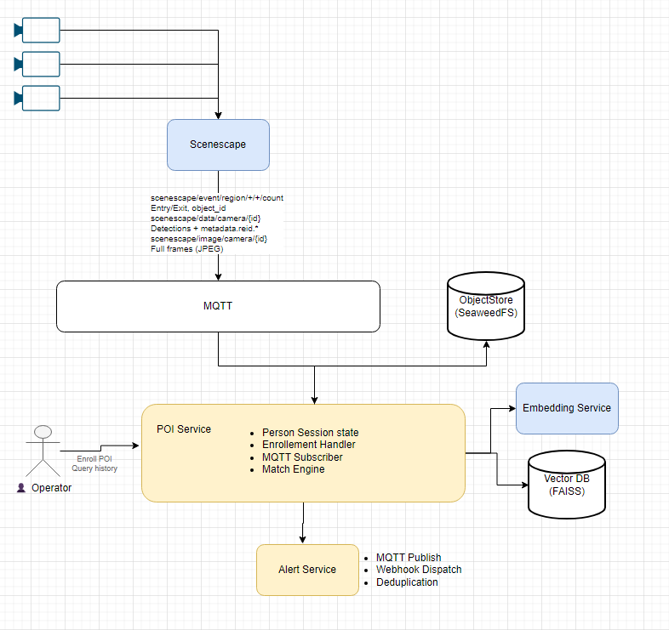

SceneScape
SceneScape is Intel's multimodal spatial analytics platform. For POI identification, we leverage:
| **Person Detection** | Detects persons in camera frames |
| **Cross-Camera Tracking** | Assigns persistent `object_id` across cameras |
| **ReID Embedding Extraction** | Extracts 256-dim reid vectors per detection |
| **Region Analytics** | Entry/exit events with dwell time |

**Key Insight**: SceneScape already extracts reid embeddings using its configured model (e.g., `person-reidentification-retail-0287`). These are published in MQTT messages under `metadata.reid.embedding_vector`. We consume these directly instead of re-extracting.

MQTT Topics

Topic Pattern | Purpose | Data Provided
scenescape/data/camera/{camera_id} | Per-camera detections with re-identification | objects[] containing id, bbox, metadata.reid.embedding_vector
scenescape/event/region/{scene_id}/{region_id}/count | Entry/exit events | object_id, event_type, dwell_time
scenescape/image/camera/{camera_id} | Full camera frames | JPEG image, image_timestamp

3.3 POIService (Application Service)
The main application service that owns all POI-related business logic.

Responsibilities:
- Subscribes to SceneScape MQTT topics
- Extracts reid vectors from detection metadata (no re-embedding needed)
- Compares against POI Gallery on every detection
- Manages session state (which POIs are currently tracked)
- Exposes REST API for enrollment and offline queries

Session State:
```python
@dataclass
class POISession:
object_id: str # SceneScape's persistent ID
matched_poi_id: str # Which POI this matches
first_seen: datetime # When first matched
last_seen: datetime # Most recent detection
cameras: Set[str] # Cameras where seen
similarity_score: float # Match confidence
```

3.4 EmbeddingService (Generic)
Extracts embeddings from **operator-uploaded images** only. Does NOT process SceneScape detections (those already have embeddings).
**Critical Requirement**: Must use the **same model** that SceneScape uses, otherwise vectors are incompatible.
**Model Options** (must match SceneScape config): #TODO: Need to confirm with Scenescape team
Model | Dimensions | Notes
person-reidentification-retail-0287 | 256 | Current OpenVINO model zoo
person-reidentification-retail-0288 | 256 | Latest in series
CLIP-ViT-B/32 | 512 | Only if SceneScape uses CLIP

3.5 POI Gallery (FAISS)

In-memory vector index for enrolled POIs only.

**Operations:**
- `enroll(image, metadata)` → Extract embedding, add to index
- `search(embedding, k=5)` → Return top-k similar POIs with scores
- `remove(poi_id)` → Delete from index

3.6 General Index (FAISS) — Phase 2
Stores embeddings for **all detected persons** to enable offline historical queries.
**Privacy Concern**: Storing biometric data for all visitors requires legal review. Deferred to Phase 2 pending approval.
4 Data Flow
4.1 POI Enrollment Flow
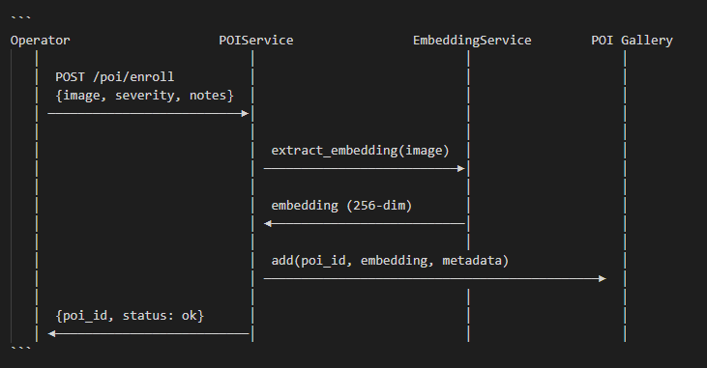

4.2 Online Mode — Real-Time Matching
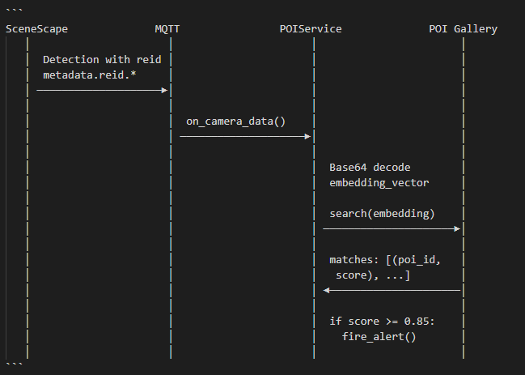
Benchmarking
Primary Metric — End-to-End Alert Latency
$$L_{e2e} = T_{alert} - T_{image}$$
$T_{image}$ : `image_timestamp` in the SceneScape image MQTT message — the camera frame capture time
$T_{alert}$ : Timestamp when `POIMatchAlert` is published
`image_timestamp` is available from SceneScape image messages (`scenescape/image/camera/{name}`) and stored alongside frames in MinIO by PersonDetectService.

Open Decisions
Embedding model : Need to confirm which model SceneScape is configured with
Open-source approval for general index : General FAISS index stores embeddings for all detected persons — confirm privacy/legal sign-off before finalising

